Thursday Bidding Tips 14 Board 21 played on 6/9/2018 Clarke Pairs
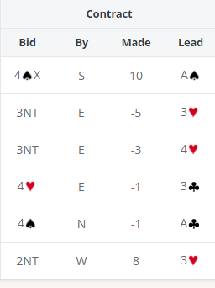
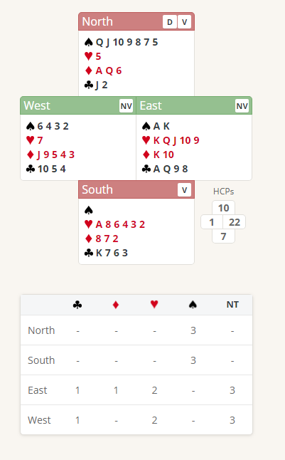

Suggested Bidding
N Dealer | E | S | W
3S | pass | Pass | pass

- Norths bid of 3 Spades shows 6-10 points and a seven-card suit
- Easts could Double which shows 12 plus points a likely shortage in the bid suit and at least 3 card cover in the other 3 suits However this means that East would either have to bid 4 Diamonds or leave in the Double for penalties with a 4 card spade suit. Both options are likely to lead to a bad board for East/West. Safer for East to pass.
- South passes

Suggested Lead from East K Hearts (top of Sequence)

Further notes about
Weak 2 and 3 openers
http://www.nzbridge.co.nz/user/inline/1754/NZB%20Beginner%2009%20-%20Student%20Notes.pdf
Takeout Double bidding
http://www.nzbridge.co.nz/user/inline/2648/NZB%20Beginner%2008%20-%20Student%20Notes.pdf

